**Lab -4**

**TEAM**

**Amit Sahu (18mis7250)**

**Gaurav Gupta(18MIS7107)**

**Propose a sample project with its Objectives, Vision statement, use cases and UML diagrams.**

**Project: Book Bazaar**

**Vision Statement:**

Saving money by reading on online system which is easy to use and manage and can be very useful to enhance readers and also for the book sellers to take feedback from the readers so that they can recommend to other people.

**Use cases:**

* User logins using his credentials.
* User will search the catelogue.
* User can view/read a book or order it.
* User will give rating for the book.
* User gives his details for shipping product.
* User gives the feedback and view the results.

**UML Diagrams**

**Use Case**

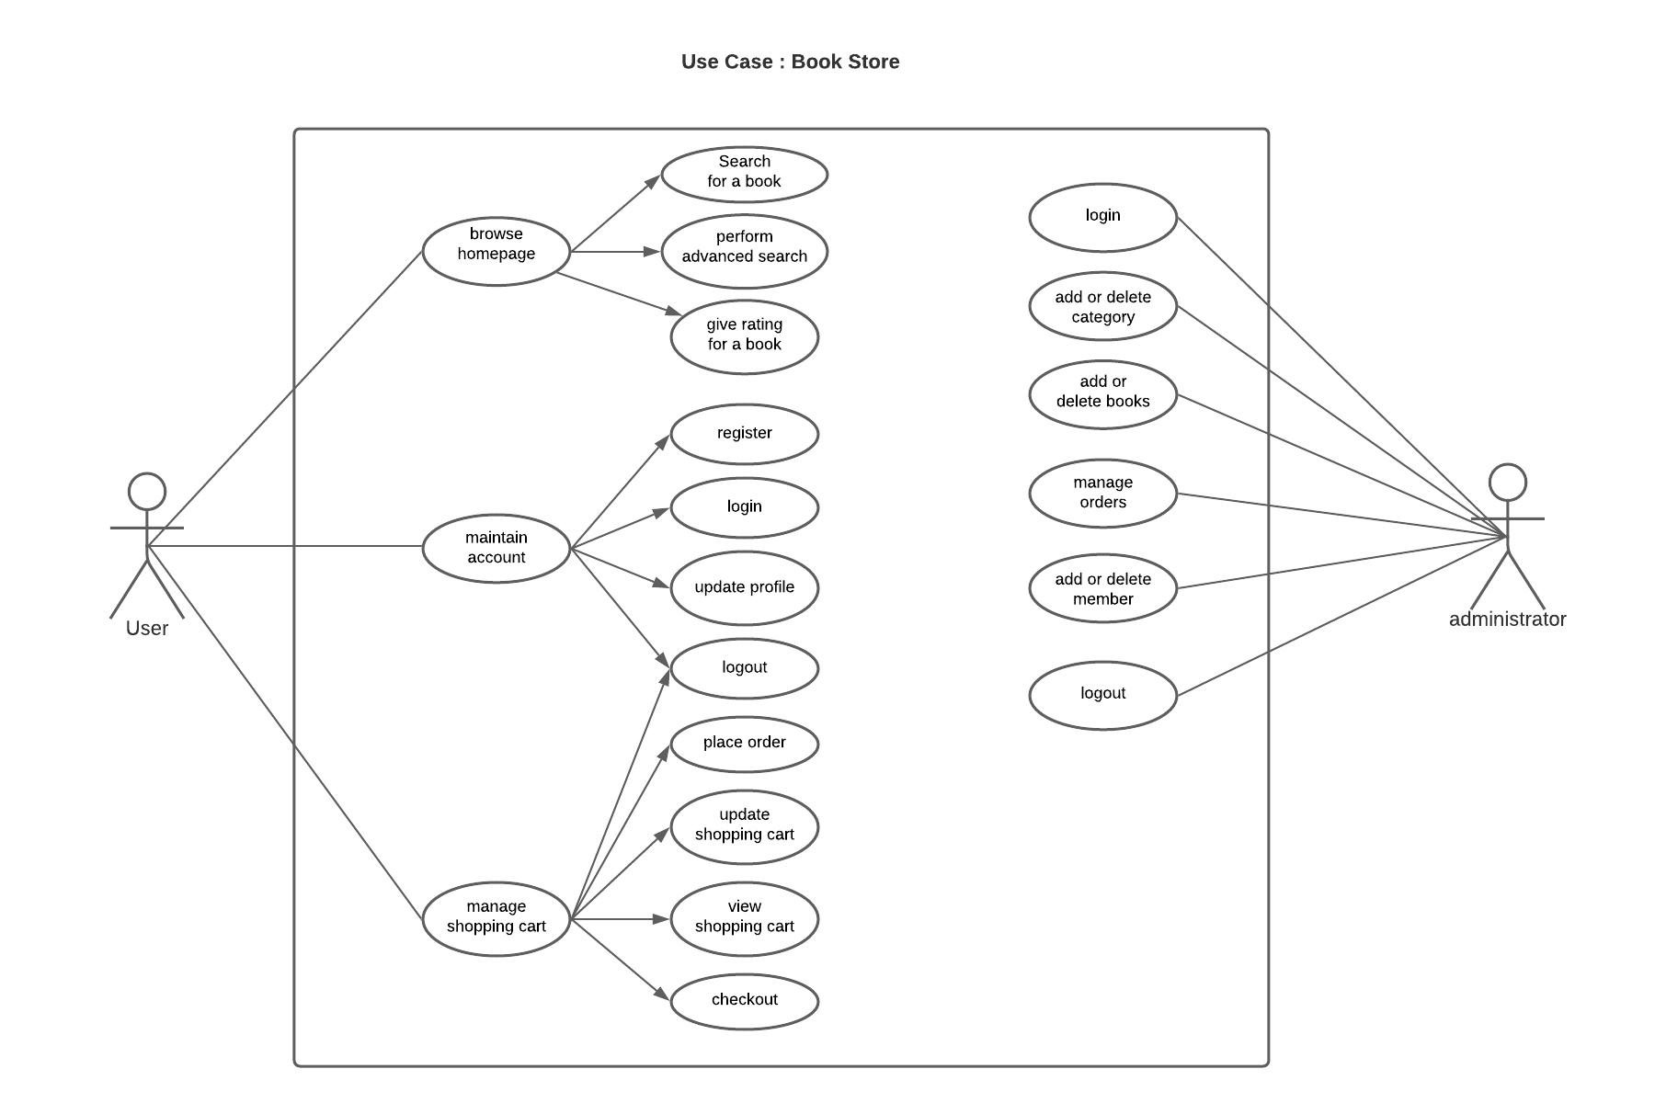

**Activity Diagram**

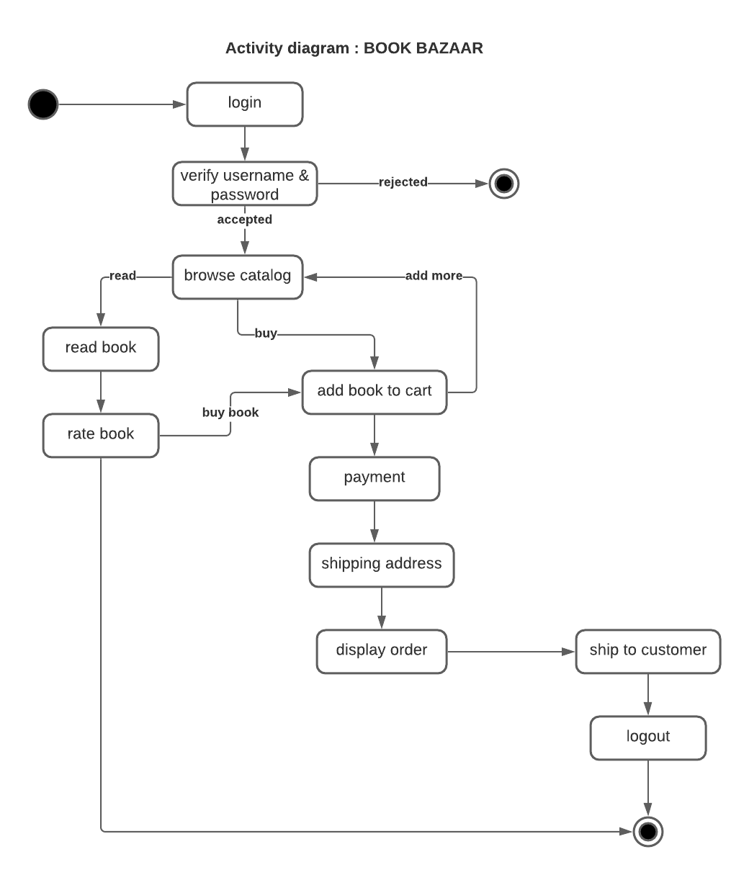

**Collaborative Diagram**

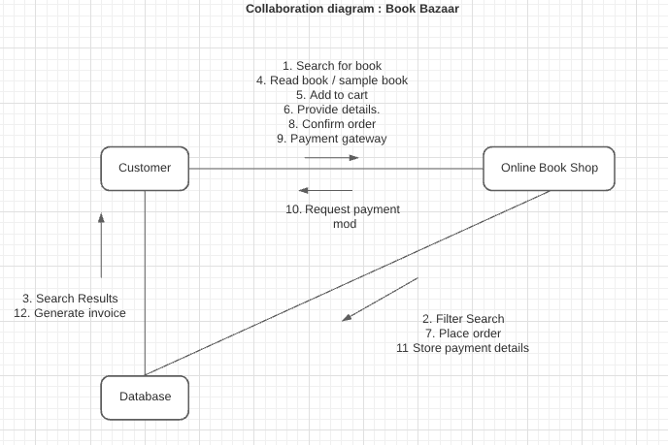

**Class Diagram**

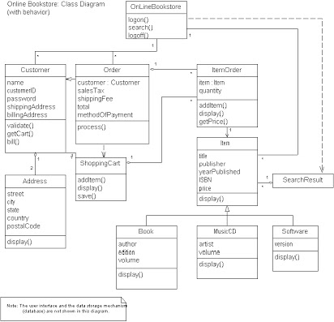

**Sequence diagram**

